Hi all you poets, authors and writers.

This week I’d like to introduce you to Haiku, a classic Japanese form of short poetry, which celebrates nature and aspects of life. They are little snapshots of moments that vary from serious reflections and images to the whimsical and uplifting. Their three-line, seventeen-syllable form compels the poet to ponder carefully what it is they want to express. Traditionally, the seventeen syllables are broken up as follows.

*First line-5 syllables*

*Second line-7 syllables*

*Third line-5 syllables*

If you’re not sure what a syllable is, it’s an uninterrupted segment of speech consisting of a vowel, a diphthong, or a syllabic consonant.

*E.g. Pie, sty, act and could are one syllable*

*Enact, ringlet and stifle are two-syllable words.*

I’ve included my own Haiku contribution below

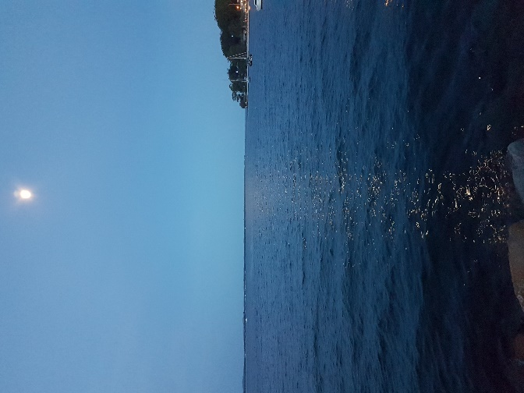

*Watery mirrors*

*Reflect a moon’s envy of*

*Sun’s doting children*

See if you can come up with your own. Would love to hear from you.

Have fun!

Annie B